Huarui Lu, Zhiwei Li, NUID:001050438

Ranking System

Spring 2020 INFO6205 Project

**Team Member**

The prediction of English Premier League in 2019-2020 season.

# Introduction

## What is Ranking System?

A ranking is a relationship between a set of items such that, for any two items, the first is either 'ranked higher than', 'ranked lower than' or 'ranked equal to' the second.[1] A ranking system is a system that analyzes the input provided by users to provide the ranking for each element.

Our task is to develop a ranking system which is able to evaluate the following expression where $x_{i}, x_{j}$ are elements from a set of competing elements $X$: $$P(x_{i}, x_{j})$$  
where $P(x_{i}, x_{j})$ is the probability that $x_{i}$ would beat $x_{j}$ if they met in a head to head matchup at neutral territory.

In this project, we created a ranking system for English Premier League (EPL). The input to our system is a set of prior encounters with a result. These results are scores of each game. The output is the probability of win-draw-lose in coming games in season 2019-2020 according to the schedule.

To present our prediction result, probability density function (PDF) is used to show the probability $P$.

## Probability Density Function

In probability theory, a probability density function (PDF), or density of a continuous random variable, is a function whose value at any given sample (or point) in the sample space (the set of possible values taken by the random variable) can be interpreted as providing a relative likelihood that the value of the random variable would equal that sample.[2]

For our project, we will use two distribution to predict the goal difference in 92 games left, one is Skellam Distribution, the other is Poisson Distribution. Especially, the Skellam Distribution can be seen as two Poisson Distribution combined.

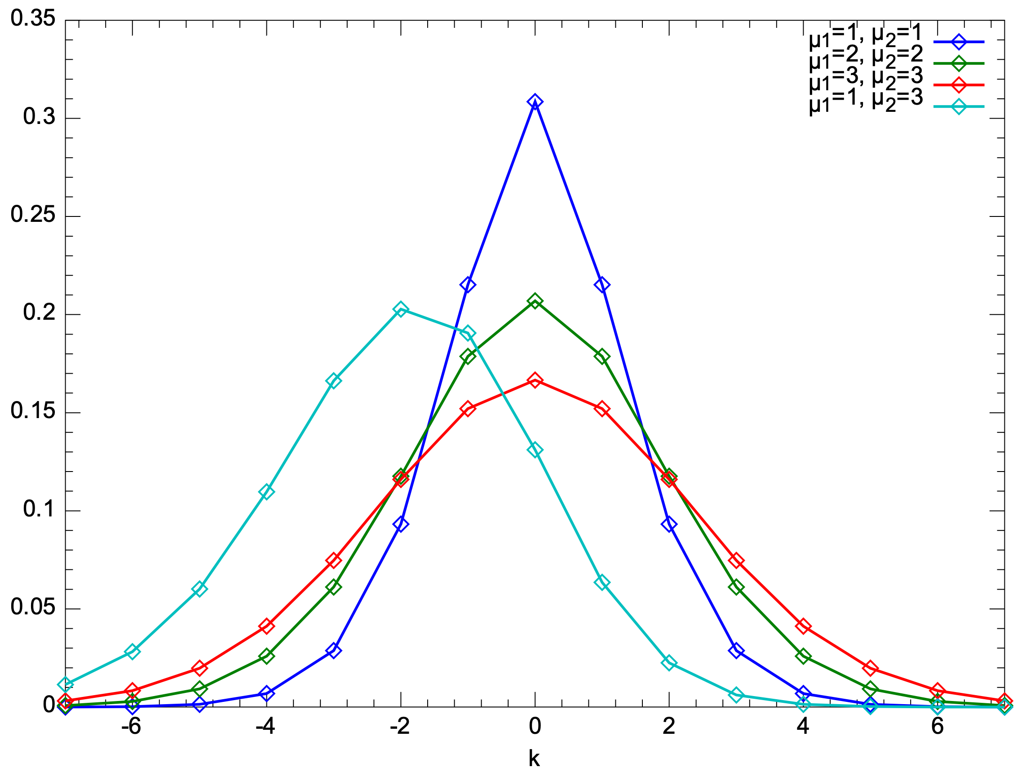

Fig.1. Probability density function of Skellam Distribution.

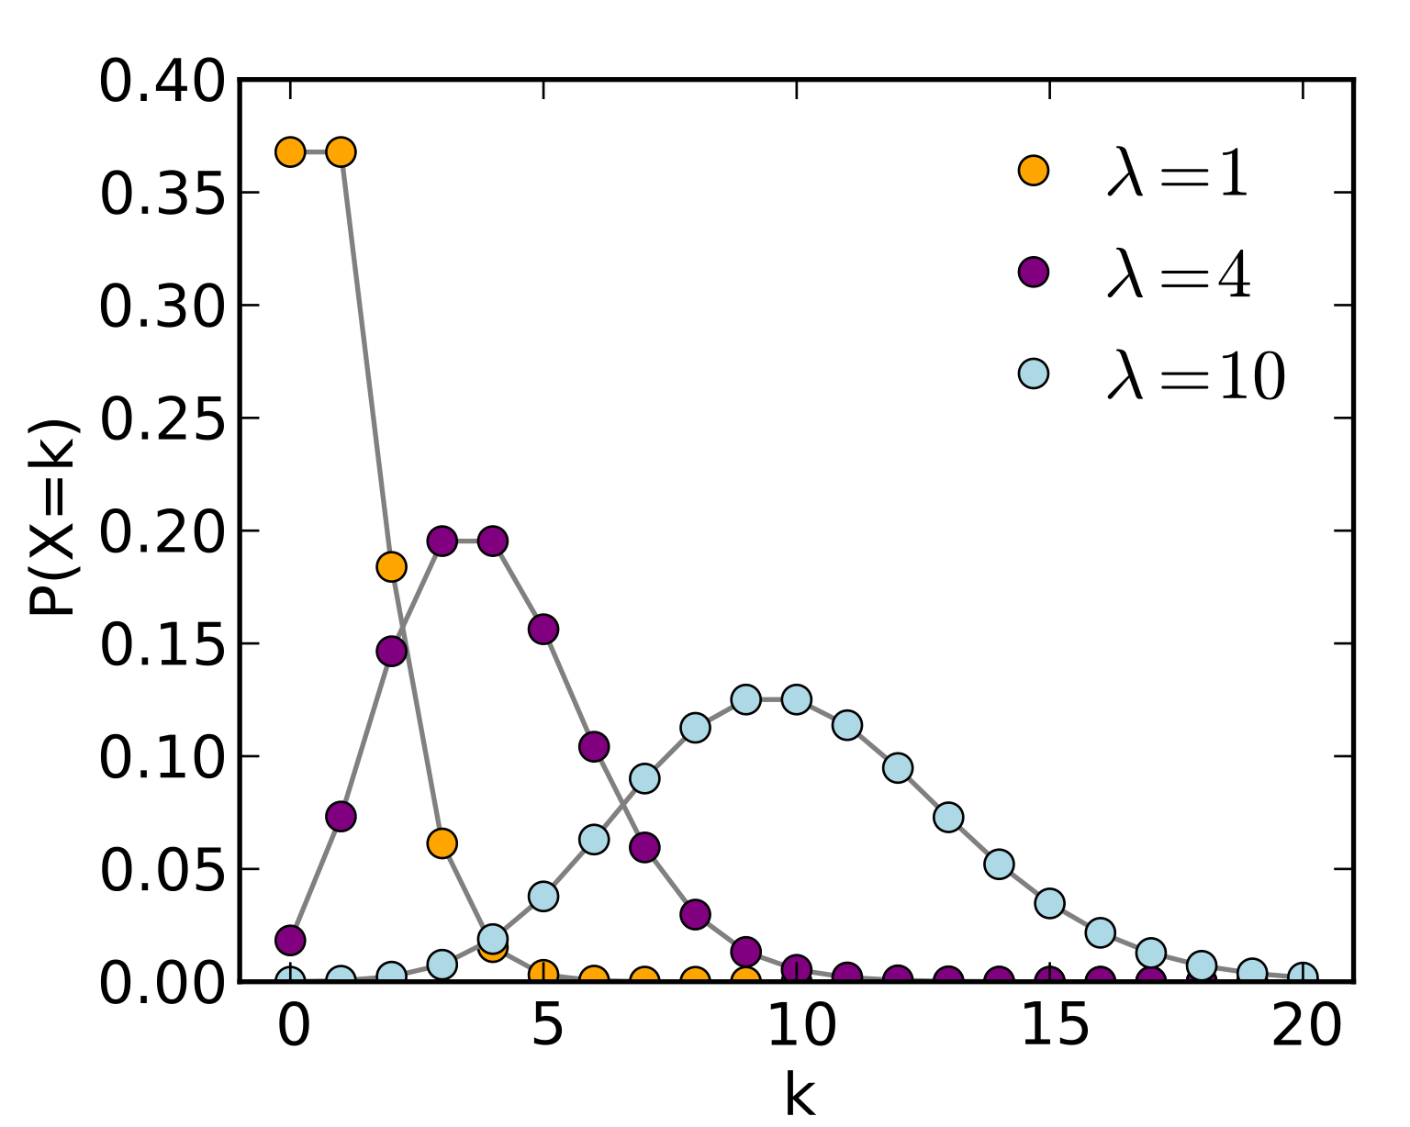

Fig.2. Probability density function of Poisson Distribution.

The probability mass function of Skellam Distribution is[3]:

And $I_{k}\left(2\sqrt{u_{1}u_{2}}\right)$ is the modified Bessel function of the first kind[4].

The probability mass function of Poisson Distribution is[5]:

# Aim of the Project

Designed the EPL Ranking System.

* Calculate the win, draw and loss probability that team A will beat team B if they meet with each other in a head to head matchup.
* Draw the probability density function for goal difference in each game.
* Predict those coming games. “Complete the season” and give a final table with 38 matches “played” by each team.
* Predict the final rank of those twenty teams with the prediction of 92 coming games.

# Dataset used in this project

In this project, dataset used by us is only EPL 2019-2020 season result (those games finished). Data is saved in a CSV file.

Fig.3. An overview of data in 2019-2020 season

For each match, we will extract the Home Team, Away Team, Home Team Goal, Away Team Goal, Result, Home Fouls Commit, Away Fouls Commit, Home Shot on Target, and Away Shot On Target as parameters to calculate the probability of the result in future.

# Project Description

1. We import dataset of the match history in 2019-2020 season by CVSReader.jar, and create nine classes which will be useful for our team to store data or realize the function my need.
2. By ELO Rating Principle[6], we primarily calculate the rank of those twenty teams by analyzing past 288 matches.
3. In light of the whole season each team will play 19 games in their home with others, 92 games need to play in the future. With team directory and match history, we can obtain the future games stored into an ArrayList.
4. Significantly, in order to want to predict the goal difference in future games, we need the average goals of each team in the past. However, the mathematical average goal, which is calculated by the total goals divided by the total number of games, could not perfectly reflect the strengthen in future games, because different team has different defensive strengthen. In light of this, we use The Possible Goal Difference of A team in each future game. For here, the Possible Goal Difference of A team equals The average number of shot on target of A team minus The average number of successful defense of B team. It is:
$$"The Possible Goal Difference of A team= The average number of shot on target of A team-The average number of successful defense of B team."$$

5. After calculating the possible goal difference of A team in each future games, We find that there are some PGD(Possible Goal Difference) is negative. If we want to use the Skellam distribution, the PGD of two teams in a game must be positive. Meanwhile, if PGD of A is negative, we can definitely assume the possible of A’s goal is 0. Now, we just use the Poisson Distribution to predict how about the B’s goal, where $λ$ is the PGD of A – PGD of B (PGD of B <0) . So we use those two distribution to predict the goal difference in the future. (All the distribution graphs are stored into main/resources, and their file type is png)
6. Finally, we need to predict the probability that home team win, draw or lose in each future games. For those predicted by Skellam Distribution, the probability of home team win is just the sum of the probability of goal difference larger than zero, the probability of draw is the probability of goal difference is zero, and the probability of lose is the probability of goal difference less than zero. For those predicted by Poisson Distribution, the probability of winner is the probability of goal difference larger than zero, the probability of draw is the probability of goal difference is zero, and the probability of lose is zero. After gaining those probability of each future match, we assume the result of future game is determined by the biggest probability of win, draw or lose. Then we rank them again to obtain the final rank result with all the 380 matches in this season.

# Implementation

## RankingSystem

## DataReader

## DrawMath

## FutureMatchDictory

## Match

## MatchDirectory

## sortHelper

## Team

## TeamDirectory

# Output

## Current Rank

## Win/Draw/Loss Probability

Fig.4 A screenshot of output in command line

## Probability Density Function Graph

Fig.5 Four examples of product density function graph.

## Final Rank

# Conclusion and Future Implementations

1. According to both rating principle, the champion will be absolutely Liverpool. And Bournemouth, Norwich and Watford will be relegated. In light of the similarity of two rating principle, we have confidence to say our prediction is approximately rational and logical.
2. In the future, we would analysis the effect of home team advantage. And quantify it into a parameter in our prediction, which make our prediction and ranking system more precise. And we could also make a GUI for our ranking system and do some visualization work, which can improve our project into an interactive system.

# References

[1] <http://www.merriam-webster.com/dictionary/ranking>

[2] Grinstead, Charles M.; Snell, J. Laurie (2009). "Conditional Probability - Discrete Conditional" (PDF). Grinstead & Snell's Introduction to Probability. Orange Grove Texts. ISBN 161610046X. Retrieved 2019-07-25.

[3] <https://en.wikipedia.org/wiki/Skellam_distribution>

[4] <https://en.wikipedia.org/wiki/Bessel_function#Modified_Bessel_functions_:_I.CE.B1.2C_K.CE.B1>

[5] <https://en.wikipedia.org/wiki/Poisson_distribution>

[6] <https://en.wikipedia.org/wiki/Elo_rating_system>